Exploring the influence of washing activities on the transfer of fibres in forensic science

Virginie Galais, Stephanie Wilson, Niamh Nic Daéid, Hervé Ménard*

 Leverhulme Research Centre for Forensic Science, University of Dundee, Dundee, DD1 4HN, UK

*Correspondence: h.menard@dundee.ac.uk

Abstract

Textiles and fibres are prevalent in modern life, extending beyond clothing to various everyday items. In forensic science, understanding fibre transfer is crucial, yet existing research lacks consistency and repeatability. This study investigates the impact of washing activities on both the release of fibres into wastewater and the transfer of fibres from donor garments to receiver swatches. Using a low-cost friction tester and automated data collection through photography and ImageJ, controlled conditions were maintained for repeatable experiments. Results indicated significant fibre release during wash cycles, with load size and donor garment history playing crucial roles. The donor garments subjected to repetitive washes exhibit a decrease in the transfer of fibres, independently of the load size. Further research into diverse fibre types and washing parameters is recommended. The study underscores the importance of considering a garment's washing history in forensic contexts.

## Introduction

Textiles and fibres are omnipresent in modern society, not just limited to clothing but also found in everyday items or objects such as furniture, surfaces, and vehicles. The ubiquitous nature of fibres and their diversity has made them valuable in forensic science, involving the study of fibres found at crime scenes or on individuals to determine their characteristics and potentially their source. Fibre transfer can occur through direct contact between individuals, leading to primary transfers, but can also transfer indirectly between two surfaces. This indirect fibre transfer is defined as an exchange of evidence with no direct contact between the original source and the location or surface on which it is retrieved. The number of indirect steps is generally unknown when referring to indirect transfer, but can be referenced as, for example, secondary transfer when it is established that just one single step occurred after the initial deposit.

In forensic science, the transfer of fibres was studied by many authors over the past 50 years, with much of this work focusing on primary transfer [1-12] and secondary transfer [3, 13-15]. From these studies, several parameters were identified to have a potential impact on the transfer of fibres, such as the fibre type, their morphology and thickness, the fabric texture and manufacture, the method of transfer and the applied pressure associated with the transfer event. Despite a relative consensus on the impact of these parameters on the transfer of fibres, the analysis of the literature highlighted a large variety of materials (i.e. textiles) and methodologies: a wide range of transfer activities have extensively been investigated, employing various techniques such as manual pressure [15, 16], twist [17], shake [3] and torsion [11]. Systems testing conditions close to real-world scenarios have also been examined in order to gain insights into legitimate activities [3, 7, 9, 12], including simulated smothering, sleeping, sitting on car seats and chairs, and wearing of items. However, a large majority of the experimental methods provided insufficient details which, combined with a paucity of data, cause issues for the reproducibility and replicability of the works. Both reproducibility and replicability are essential to scientific data integrity and validity as they enhance the reliability of the results while also posing challenges to making meaningful comparisons.

A research area that remains relatively unexplored in forensic science is the impact of washing activities on the transfer of fibre. While the task of laundering garments is part of people routine, publications in forensic science about laundry mainly focused on the persistence of biological fluids [18-21] or the persistence of fibres [3, 15-17]. One study by Bresee and Annis [5] was dedicated to the effect of the use of softener in the transfer of fibres. This study is a pioneer for the effects of washing in fibre transfer, however, the authors did not use detergent, and it is therefore difficult to identify the different parameters of the washing process that have an impact on the transfer, for example, the mechanical damage itself produced by the drum of the washing machine.

To address these gaps, this work aimed to design a universal protocol (i.e., repeatable, practical, and transparent) for data collection and analysis for future research in fibres in forensic science. This study focusses on the validation of this method by studying the effect of repetitive washes on the transfer of fibres from donor to receiver garments. The second aim of this work was to study the impact of washing activities on the release of fibres into the wastewater associated with the washing cycle.

## Material and Methods

### Donor garments

The donor garments selected were identical women’s round neck knitted jumpers of 100 % cotton, colour red, size 16 and 12 (Figure 1-A). The average number of stitches per cm2 was found to be approximately 63. Each garment to be washed was given an identification number attached to its label. One garment was kept as a control garment (i.e., never washed). A total of 10 distinct contact areas (CA) of 20 cm × 3 cm strips, shown in Figure 1-A, were identified on each donor garment using a paper template of an overall size of 27 cm × 46 cm. Five contact areas have their length aligned parallel to the knit of the garment (annotated CA1 to CA5) and 5 perpendicular to the knit of the garments (annotated CA6 to CA10). Figure 1-B shows the parallel and the perpendicular orientation.

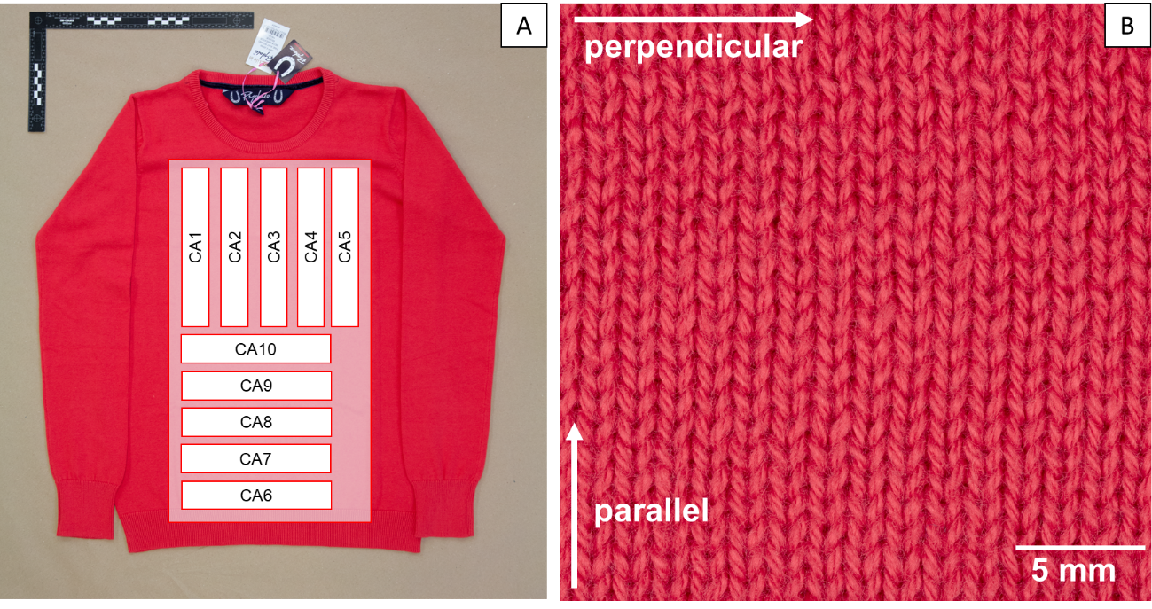

Figure 1: 100 % cotton donor garment, with (A) the full garment with the location of 10 contact areas (CA), (B) details of the mesh, the arrow showing the perpendicular and parallel orientations on the mesh.

### Receiver garments

The recipient textile selected for all the experiments was a plain (white) weave fabric, made of light to medium weight 100 % cotton of approximately 111 g/m2, see Figure 2-A. For the transfer and persistence experiments, the recipient textile was cut into 5 cm × 5 cm and attached to a Perspex cube presented in Figure 2-B. To preserve the textile properties such as strength, flexibility and elasticity, each piece of textile was tied to the Perspex cubes without being stretched. The samples were stored in metal boxes to prevent contamination and electrostatic effect. Each sample was only used once per experiment.

A positive control (recipient swatch) was created by performing a transfer on the control donor textile (as received and never washed) with an 800 g weight for a 20 cm length. The negative control was a Perspex block with recipient textile, but with no transfer performed. Both controls were stored in the same box to enable an exploration of storage-related cross-contamination to be undertaken.

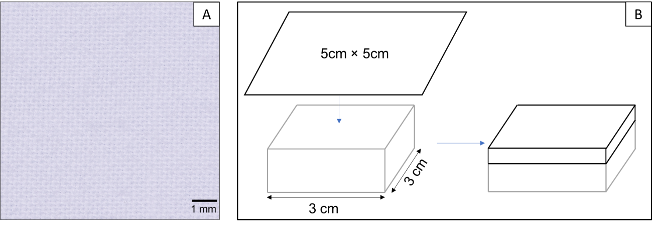

Figure 2: Receiver textile, in (A) details of the mesh, (B) Recipient swatches: a piece of recipient garment is placed on top of a 3 cm × 3 cm Perspex block.

### Washing activities

The washing machine used for this study was a Montpellier, model MW7140S, 7 kg load. Two different cycles were selected for the experiment, one to wash the garments (60 min - daily wash programme of the machine, 40 degrees, 1200 rpm) and one to clean the washing machine after each washing cycle (15 min- rapid wash programme of the machine, no spin, no set temperature). The rinsing cycles were found necessary to remove fibres remaining in the washing machine after the donors were washed and were performed 4 to 6 times.

A water filtering system was designed to collect fibres from the wastewater, as shown in Figure 3-A. Once the wash cycle was over, the volume of wastewater was measured on a graduated scale placed on the side of the barrel (uncertainty calculation for the graduation of the barrel is available in supplementary information). After each wash cycle, the wastewater was manually stirred to homogenise the distribution of the fibres and filtered using a stainless-steel (Spectra Mesh®, 90 mm diameter, 105 μm), see Figure 3-C) clamped in a purposely designed Perspex holder (Figure 3-B). Once dry, the filters were weighed with a precision laboratory balance (Mettler AT200) alongside a reference filter before and after filtration. Their respective weights were recorded, and the mass of fibres was calculated as the difference of the mass of the filter after and before filtration, normalised to the reference filter. An example of mass recording for a given experiment as well as the uncertainty calculation is available in the supplementary information.

The donor garments were simultaneously and repetitively washed without laundry detergent, under the same washing condition (60 min, 40 degrees, 1200 rpm). After each wash, the donor garments were left to air dry for a minimum of 20h, on a drying rack covered with brown paper to limit possible contamination.

A total of three different set of repetitive washing activities were performed: The first set involved washing a single donor garment (size 16), simulating a small load, the second set consisted of washing 5 donor garments (size 16) simulating a medium load and the third set consisted of washing 12 donor garments (size 12) simulating a normal load. The repetitive wash cycles were carried out until a plateau in the number of transferred fibres between wash cycles was reached: this corresponded to n=15, n=51 and n=41 respectively for the 1st, 2nd and 3rd experiment.

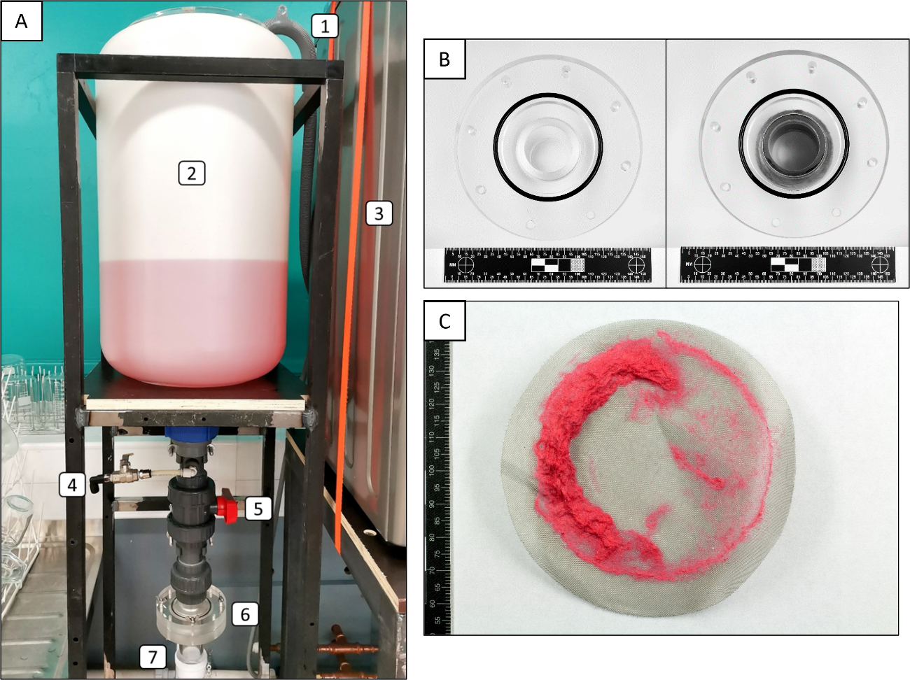

Figure 3: Filtration system, with in (A) filtration device: (1) washing machine waste pipe, (2) water bottle, (3) washing machine, (4) small valve, (5) big valve, (6) stainless steel filter holder, (7) general waste pipe.  
(B) Stainless steel filter holder - two rings joined and held in place by screws.  
(C) Stainless steel filter with red fibres from a wash.

### Transfer activities

A low-cost transfer device was built, based on the Arduino-Based uniaxial Tensile Tester developed by Arrizabalaga *et al.* [22]. The transfer device was made of a wooden frame with a sliding rail on each side to guide the moving platform on which a load cell was mounted, see Figure 4. A load cell was connected to an Arduino Uno microcontroller (physical programmable circuit board), itself connected to an Integrated Development Environment (IDE). A linear actuator, controlled with Double Pole Double Throw (DPDT) 3 positions momentary rocker switch was attached to the moving central platform to allow linear up and down displacement. A metallic chain was used to connect the load cell to the square frame purposely designed to surround and pull the Perspex block with its recipient swatch. A pulley plumb to the load cell allowed the linear upward movement to be directly translated into a horizontal displacement, a straight-line motion in one direction. The list of components, software codes to read data from the Arduino apparatus and instructions are available in the supplementary information.

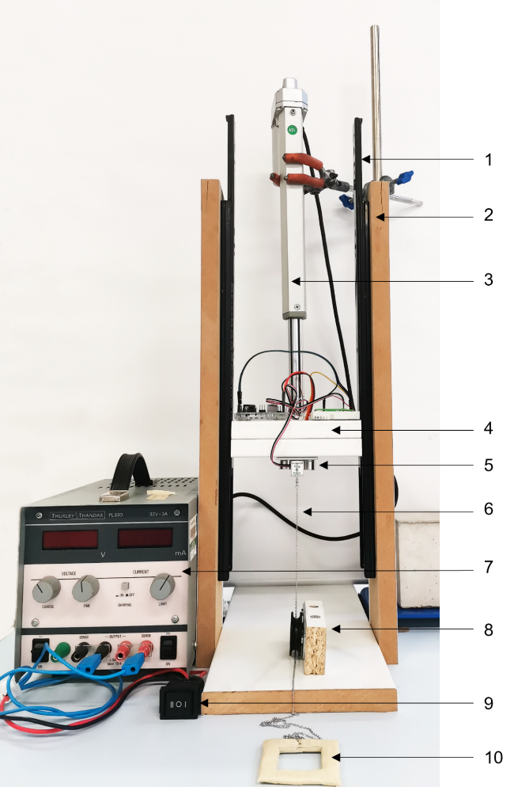

Figure 4: Transfer device, with in (1) Drawer slides, (2) Wooden frame, (3) Linear actuator, (4) Central loading apparatus, (5) 5 kg load cell, (6) Metal chain, (7) Generator, (8) Pulley, (9) DPDT 3 position momentary rocker switch, (10) pulling frame.

For each single transfer, a receiver swatch was placed on top of the donor garment (textile on textile), with the pulling frame fitted around the Perspex block. The metal chain was positioned and aligned to the top of the block. An 800 g weight was added on top of the receiver swatch. The Arduino interface (IDE) was then run to record the time and the load during the transfer. Once the data recording was launched, the rocker switch was flipped to start the linear actuator before being switched off once the Perspex block travelled the full 20 cm (end stop of the linear actuator, travelling speed 29 mm/s). The receiver swatch was then removed from the pulling frame and securely placed back in a metal box (2 samples per box).

Transfers were performed on the predefined contact areas (20 cm × 3 cm) on each donor garments, with their locations identified by using a paper pattern. To reduce folding during the transfer experiments, each garment was held in place with flat weights (clean metal bars). For the first set of experiments (i.e., 1 single garment washed), all the ten contact areas were used for transfer after each wash. For the second set of experiments (i.e., 5 garments washed together) some of the contact areas on the five garments were used for transfer after each wash, while others were subject to transfer every 2 washes, 5 washes or every 10 washes. For the third set of experiments (i.e., 12 garment washed together), all the ten contact areas on three garments out of the 12 garments washed together were used for transfer after each wash (details available in the supplementary information).

In parallel to the transfer performed between washes, 100 repetitive transfers on 4 different areas on the control garments were performed, for a total of 400 transfers.

### Photography and fibre counting

A Nikon D5600 Digital SLR Camera coupled to a macro lens (Nikon 60mm f2.8 D AF Micro Nikkor Lens) was used to take photos of the receiver swatches. The camera was powered using an external power supply and mounted on a Kaiser Copy Stand. The receiver swatches were illuminated by a LED lighting unit (Kaiser - 2 × 27 w, 5600 K). To prevent camera shake, all the photos were taken using a remote shutter release (Nikon MC-DC2). The camera settings used for the experimental scenarios were the following: ISO 100, f/16, 1/80 s.

Prior to every series of receiver swatches photographs, a classic nano ColorChecker® (24 colour patch, 24 × 40 mm) was photographed. The positive and negative control swatches were also photographed at each photos series to verify the acquisition procedure.

Fibre counting was performed by analysing the photographs of the receiver swatches using ImageJ software after calibration with the nano ColorChecker® and the Adobe Bridge software. A script was written to automatically crop the photographs, define a colour threshold, and count the fibres (See supplementary information). The L*a*b* colour space was chosen for the analysis, and Figure 5 shows an example of a receiver swatch before and after being processed in ImageJ.

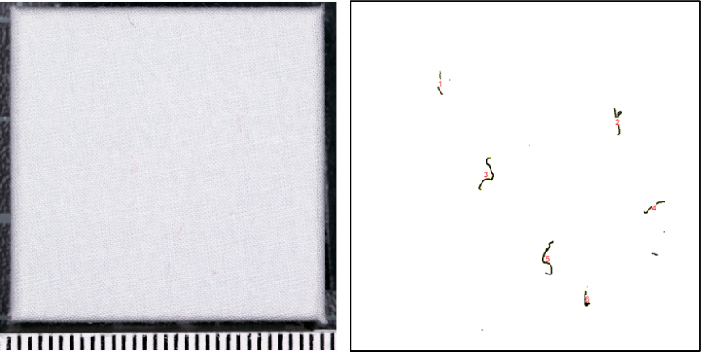

Figure 5: Fibre counting with ImageJ. On the left, photo of the recipient sample after a transfer with the red donor. On the right, the same sample after proceeding in ImageJ.

All receiver swatches were photographed prior to the transfer experiments and after the transfer was performed. The number of transferred fibres was determined by subtracting the number of fibres detected with ImageJ on the swatches before transfer to the number of fibres detected on the swatches after transfer.

## Results

### Volume of water released during washing activities.

Figure 6 shows the volume of wastewater during each of the three conducted experiments: washing a single garment (1st Exp), washing five garments together (2nd Exp), and washing twelve garments together (3rd Exp). The full dataset is available in the supplementary information. The average volume of wastewater released was respectively of 21.95 L (SD = 0.70 L), 23.88 L (SD = 1.91 L) and 23.40 L (SD = 1.47 L) for the three experiments. The wastewater volume released during each wash remained relatively stable in the 1st experiments, however the 2nd and 3rd experiment exhibited significant fluctuations, as evidenced by the higher standard deviation.

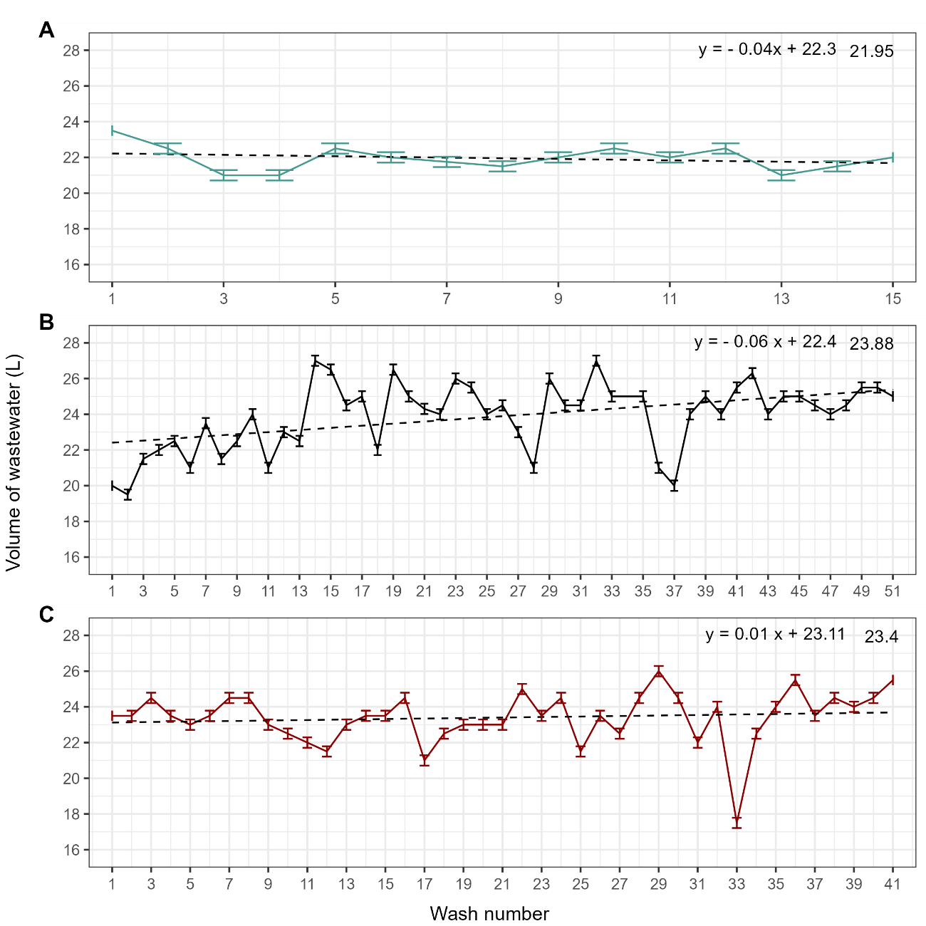

Figure 6: Wastewater volume released (L) during the washing cycle series, A) results obtained with washing one garment 15 times, B) results obtained with washing five garments 51 times and C) results obtained with washing twelves garments 41 times. Wash number 34 not represented in B) due to an issue during data collection. The dashed line represents the linear regressions, and each equation is displayed in the top right. The error bars displayed correspond to uncertainty linked to the calibration of the barrel and the reading standard uncertainty (± 2U). The averages are displayed on the top right of each plot.

Mass of fibres released in the wastewater during washing activities

Figure 7 shows the mass of fibres (mg) released in the wastewater normalised to the weight of the garment, as a function of the wash cycles performed, for the three conditions tested: one garment (343 g), 5 garments (1543 g) and 12 garments (3075 g). Descriptive statistics are presented in Table 1 and the raw data are available in the supplementary information. A Pearson correlation coefficient was calculated to measure the strength of the linear association between the mass of fibres released in the wastewater and the volume of water used to wash the donor garments. The correlation coefficients were as follows: 0.22 (p-value = 0.42) for the 1st Exp, 0.36 (p-value = 0.011) for the 2nd Exp, and 0.05 (p-value = 0.77) for the 3rd Exp (figures available in supplementary information). These results indicated a positive correlation between the mass of fibres released in the wastewater and the volume of water used only in the 2nd experiment. However, no such correlation was observed in the other two experiments (p-value > 0.05).

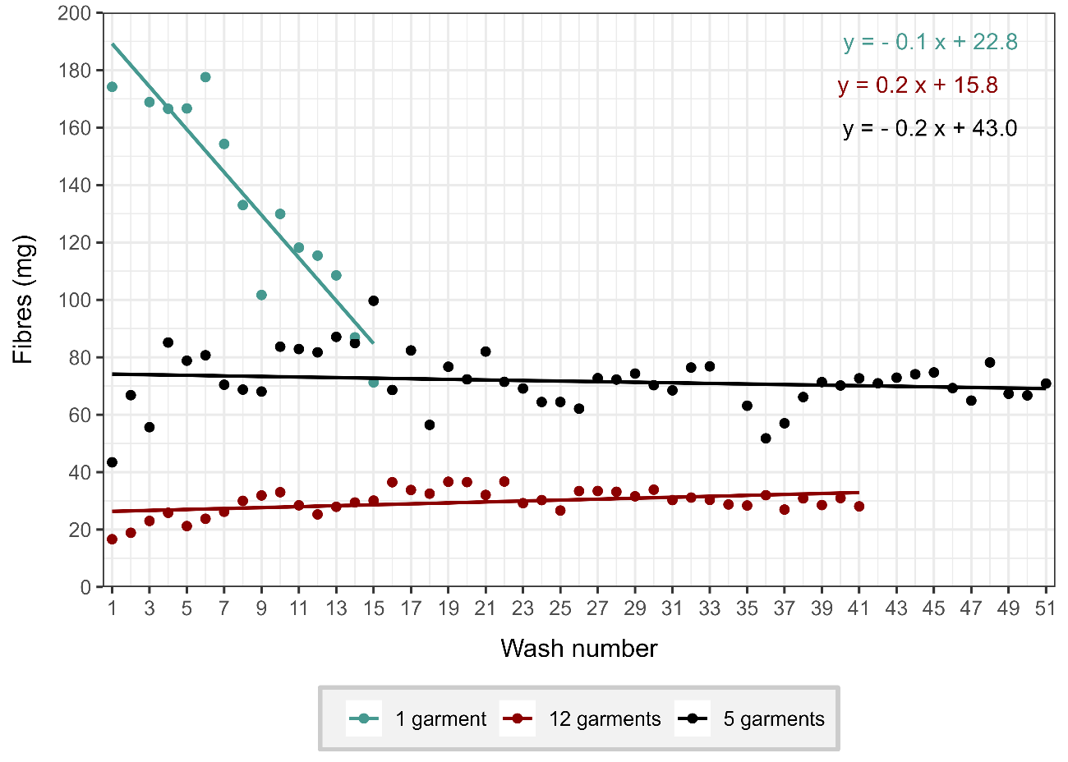

Figure 7 : Mass of fibres (mg) released in the wastewater normalised to the weight of the garment, as a function of the wash cycles performed, for each experiment

: the 1st Exp in green (one garment - 343 g), the 2nd Exp in black (5 garments -1543 g) and the 3rd Exp in black (12 garments - 3075 g). The lines represent the linear regressions, and the equations are displayed in the top right.

Table 1: Mass of fibres (mg) released in the wastewater from for each experiment. In bracket is indicated the mass of fibres released in the wastewater normalised to the weight of the garment. *SD corresponds to the standard deviation. ** SEM correspond to the standard error of the mean

|  |  |  |  |
| --- | --- | --- | --- |
|  | 1 garment | 5 garments | 12 garments |
| Wash cycle | n =15 | n = 51 | n = 41 |
| minimum (mg) | 24.44 (71.25) | 67.00 (43.42) | 51.18 (0.04) |
| maximum (mg) | 72.56 (211.55) | 153.78 (99.66) | 112.94 (36.73) |
| Average (mg) | 47.67 (138.97) | 110.51 (71.62) | 91.07 (28.86) |
| Median (mg) | 45.62 (133.00) | 109.78 (71.15) | 93.06 (30.10) |
| SD* (mg) | 13.40 (39.06) | 14.98 (9.71) | 13.95 (6.47) |
| SEM** (mg) | 3.46 (10.09) | 2.12 (1.37) | 2.18 (1.01) |

### Transfer experiments

#### Garment inter and intra variability

The average number of fibres transferred after each wash, for each of the garments washed in the 2nd (n=5) and 3rd Exp (transfer n=3, washed n=12), are shown in Figure 10. A consistent pattern can be observed in the number of fibres recovered across the repetitive wash cycles for all five garments.

When five garments were washed together (2nd Exp), the average standard deviation across wash cycles was 1.18 fibres, with a minimum of 0.19 (wash cycle 49) and a maximum of 3.66 fibres (wash cycle 4). Similarly, for twelve garments washed in the same batch, the average standard deviation across wash cycles was 0.87 fibres, with a minimum of 0.15 (wash cycle 35) and a maximum of 2.25 fibres (wash cycle 1). These results suggest that when a higher number of garments are washed simultaneously, there is a reduced level of variability in the remaining transferred fibre counts following each washing cycle. Furthermore, the level of variability tends to increase with the quantity of transferred fibres. In general, this illustrated that there was minimal variation between garments in terms of fibre count, indicating low garment-to-garment variability.

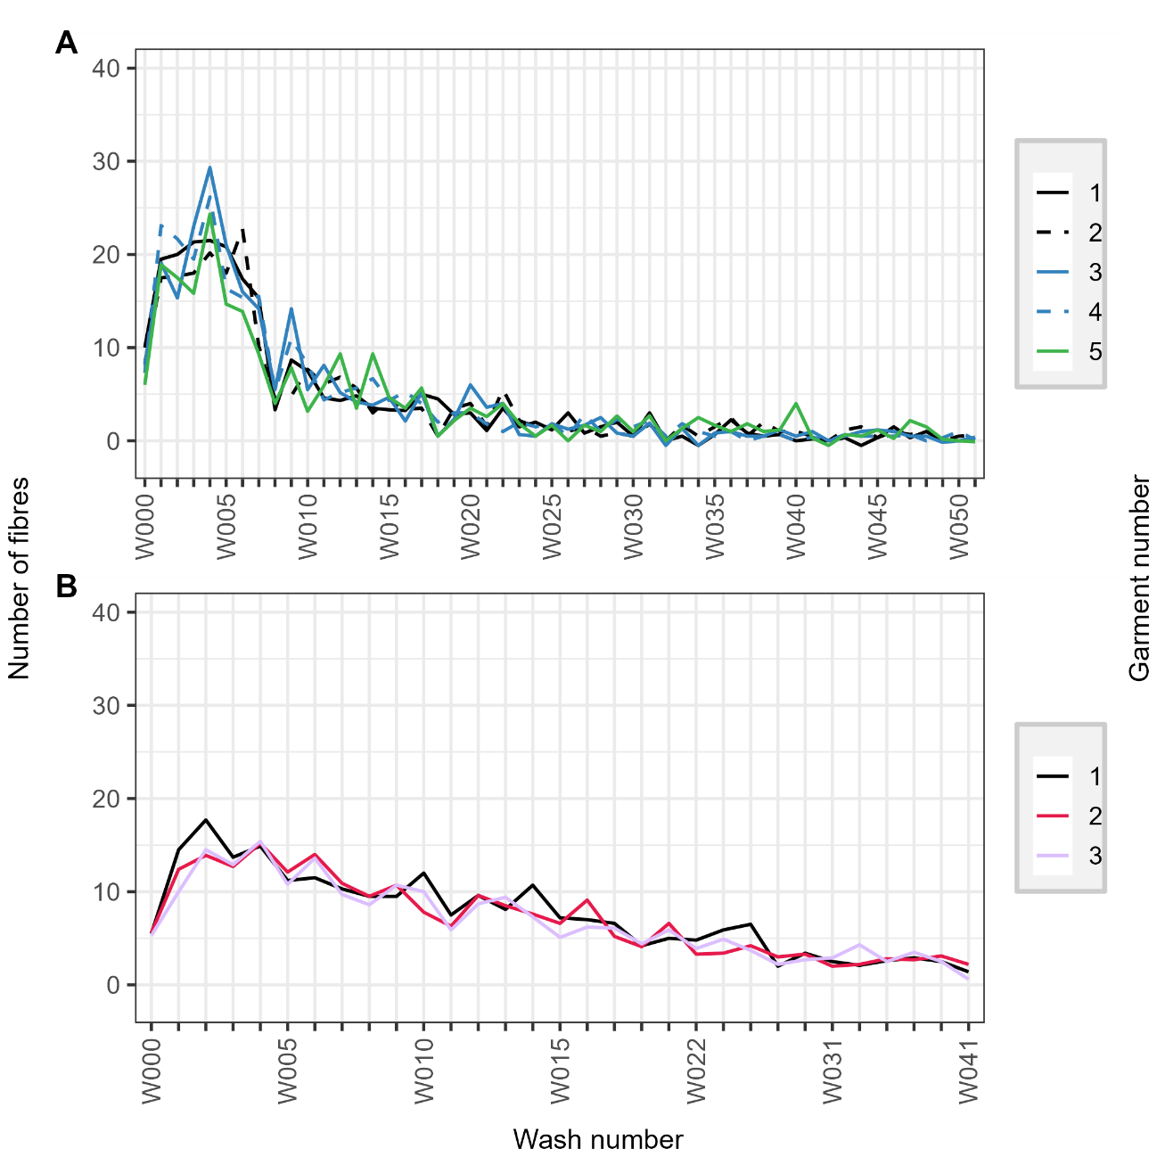

Figure 10: Number of fibres recovered after transfer over the wash per garment, all contact areas combined per garment. A) results obtained with washing 5 garments 51 times, B) results obtained with washing twelves garments 41 times. W000 correspond to the number of fibres recovered after transfer before the first wash.

Garment intra-variabilities using the knit orientation of the garment in relation to the transfer movement were tested with the garment washed alone, and the results are available in the supplementary information. A consistent pattern was observed in the number of fibres recovered across the repetitive wash cycles for all contact areas. For the contact areas parallel to the knit of the garment, the average standard deviation across the wash cycles was 1.73 fibres with a minimum of 0.55 (wash cycle 9) and a maximum of 6.07 fibres (before the first wash cycle). In contrast, for the contact areas perpendicular to the knit, the average standard deviation was 1.18 fibres with a minimum of 0.45 (wash cycle 9) and a maximum of 2.17 fibres (wash cycle 1). When considering all contact areas collectively, the average standard deviation across the wash cycles was 0.49 fibres, with a minimum of 0.44 (wash cycle 9) and a maximum of 4.47 fibres (wash cycle 1). Considering these findings, all contact areas and garments washed under similar conditions were collectively analysed.

#### Transfer on washed garments

The average number of fibres transferred after each wash for each of the three conditions tested are presented in Figure 9 (full details in supplementary information). For the 1st Exp (1 garment washed), the number of transferred fibres is seen to increase after the first wash, from 5.9 fibres (SD = 2.0) on average prior to the first wash (i.e., W000) to 9.2 (SD = 4.3) after the first wash cycle (W001). This is then followed by an exponential decay in the subsequent data points followed by a plateau reached after the sixth wash cycle. For the 2nd Exp (5 garments washed together), the number of transferred fibres is seen to increase in the first 5 data points, covering the transfer before the first wash and the first 4 wash cycles, from 7.9 fibres on average (SD = 3.5) to 24.3 fibres on average (SD = 6.4). This is then followed by an exponential decay in the subsequent data points, a plateau was reached after the 30th wash cycle. In the 3rd Exp, the initial fibre count stood at 5.5 ± 3.1 before the first wash and reached its peak at 15.4 ± 5.2 fibres after the second wash cycle, showing a moderate increase in fibre transfer. The stabilisation phase, however, was relatively extended, with the fibres stabilising at 2.4 ± 2.3 after the 27th wash cycle.

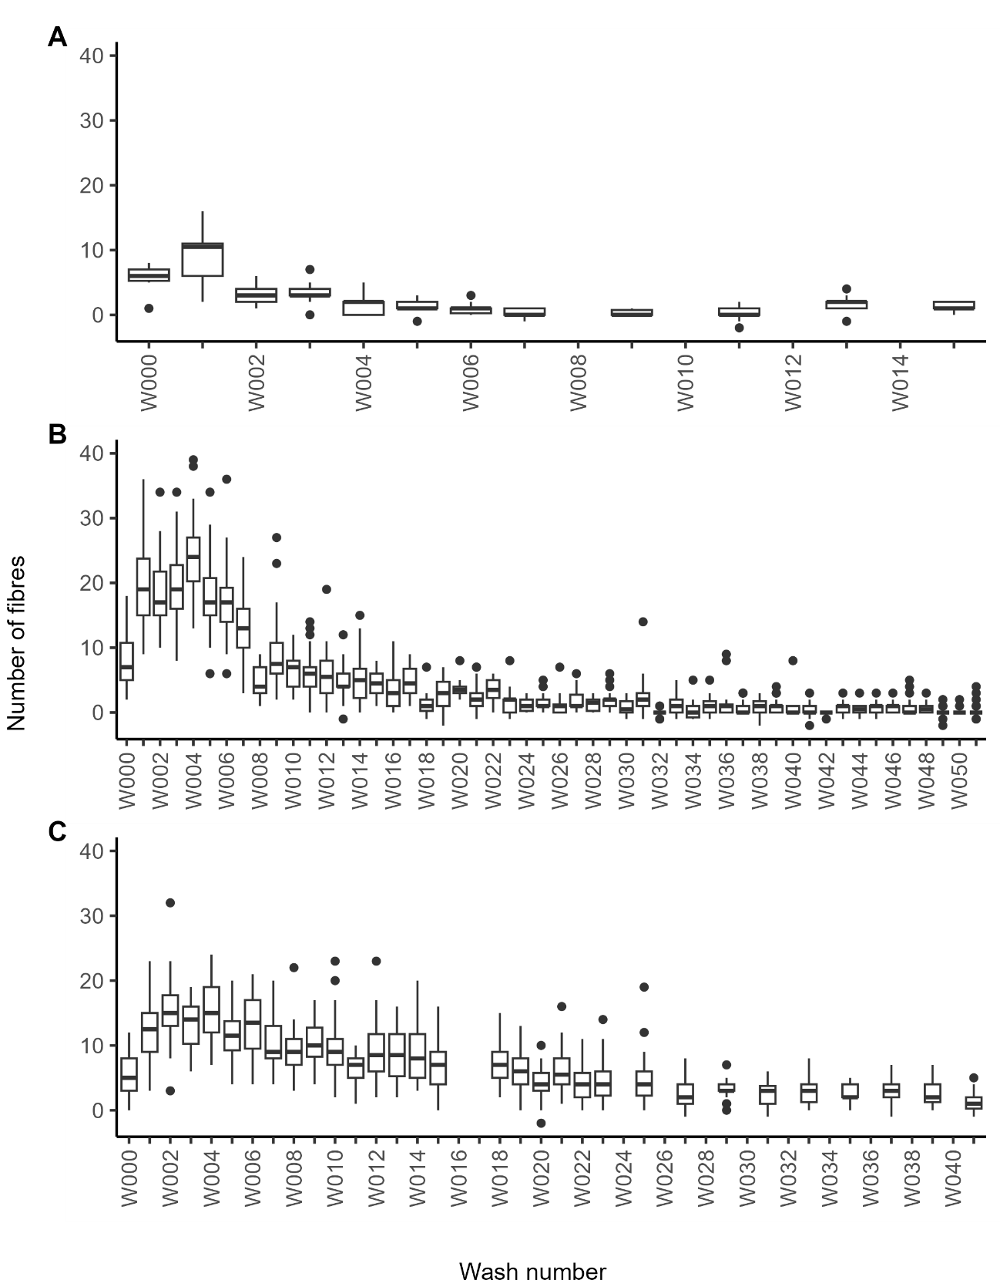

Figure 9: Number of transferred fibres (fibre counts following transfers – fibre counts before transfer), all garments and contact areas combined. A) results obtained with washing one garment 15 times, B) results obtained with washing five garments 51 times and C) results obtained with washing twelves garments 41 times - fibre counts following transfers used for W018 due to issue during data collection. W000 correspond to the number of fibres recovered following transfer before the first wash.

#### Fibre count – Washing activities vs control garment.

Figure 12 represents the average number of fibres transferred from the four contact areas following the first 52 repetitive transfers performed with the control garment (i.e., transfer without washing), in comparison to the average number of fibres transferred on the receiver swatches following the washing activities performed in the other three experiments. The maximum average for the repetitive transfer was 7.75 fibres compared to respectively 9.2 (1st Exp), 24.3 (2nd Exp) and 15.4 (3rd Exp) for the transfer with washing activities. While the number of fibres generated with the repetitive transfers remained overall constant, the washing activities have contributed to a steady decline in the number of fibres transferred over time.

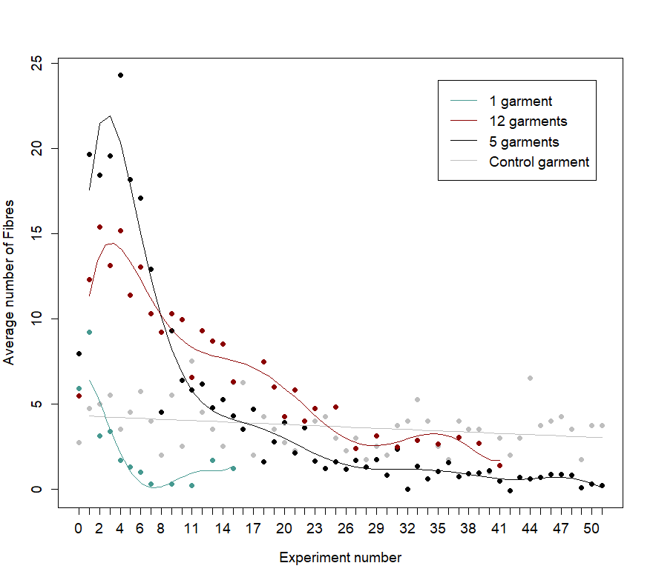

Figure 12: Comparison between the repetitive transfer and the washing activities

in the fibre production and detection during transfer. The grey line represents the linear regression for the repetitive transfer, the green line the fifth order polynomial for the washing activities performed with 1 garment, the black line the nineth order polynomial for the washing activities performed with 5 garments and the red line the nineth order polynomial for the washing activities performed with 12 garments.

## Discussion

In this study, an examination was conducted on the release of fibres in the wastewater, across repetitive washes, with 100 % knitted cotton jumpers. In their work, Kelly et al. [23] observed a decrease of microfibres released from cotton garments as the number of wash cycles increased, with an average quantity of 124.37 ± 14.40 mg/kg of fibres in the first cycle and a constant decrease until reaching 45.57 ± 2.43 mg/kg by the 4th cycle. This trend is also reported in other studies such as Zambrano et al. [24], with a decrease of 100 mg/kg from cycle one to 60 mg/kg for the 3rd cycle, and in the study of Cesa et al. [25], with 551.72 mg/kg for the first wash cycle and 154.48 mg/kg for the 3rd cycle. With synthetic garments, other studies such as Napper and Thompson [26], Pirc et al. [27], and De Falco et al. [28] have also reported a trend of decreasing microfibres released with increasing the number of wash cycles. In this study, an examination was conducted on the release of fibres in the wastewater across repetitive washes, with three different load size. The results indicated a constant decrease of the mass of fibres released in the 1st Exp, from 162.04 ± 0.52 mg/kg in the first cycle to 151.2 ± 0.64 mg/kg by the fourth cycle, aligning with the findings of the previous studies. However, an increase in the mass of fibres released was observed with the two experiments in the first four cycles, from 43.71 ± 0.01 mg/kg in the first cycle to 85.69 ± 0.01 mg/kg by the fourth wash (2nd Exp), and 13.43 ± 0.04 mg/kg in the first cycle to 22.08 ± 0.04 mg/kg by the fourth wash (3rd Exp). However, the previous studies mentioned above [23-25] have shown that the release of microfibres reaches a steady state after 4-10 wash cycles, which is consistent with the findings of this study with the 2nd and 3rd Exp. While the mass of fibres retrieved in the three experiments remained relatively similar to the mass of microfibres released from the study of Kelly et al. [23] and Zambrano et al. [24], it was notably lower than the numbers reported by Cesa et al. [25]. The discrepancies observed in the current study and the studies cited above are likely to be due to the type of washing machine used, the load size and the type of garments used.

In this work, a domestic washing machine was used, with the quantity of garments washed to represent a small load (1st Exp), an average load (2nd Exp) and a full load (3rd Exp). The results for the three experiments indicated a mass of fibres released in the wastewater in the first wash cycle of 162.04 ± 0.52 mg of fibres released per kg of garments in the load (mg/kg) with one single garment washed (1st Exp), 44.66 ± 0.15 mg/kg with five garments washed together (2nd Exp), and 13.43 ± 0.04 mg/kg with twelves garments washed together (3rd Exp). A study from Scheid *et al.* [29] highlighted the impact of load size on fibre release and demonstrated that a reduced load leads to a significant increase in mechanical action in a washing machine. This is in accordance with the results obtained in the current study where the lowest load size (1st Exp) generated the highest number of fibres in the first wash cycle per kg of garments in the load. Conversely, Kelly et al. [23] found that a higher mechanical action does not lead to a higher release of polyester microfibres, however the water volume does. The results obtained in the current study showed high variations in the volume of water used per wash, between 19.5 L and 27 L, which, according to Kelly *et al.* [23], could impact the release of fibres. However, the Pearson correlation carried out in this study did not show clear evidence that the water volume has an impact on the number of fibres released. The user’s manual and technical information of the Montpellier washing machine used in the current study do not specify the typical volume of water per wash cycle. Without further testing, the possible reasons for the variation in water consumption could not be established, but such parameters are still important to record as it defines the conditions under which the data were collected.

Mechanical agitation during washing can alter textile structures, leading to damage. A study by Candan and Önal [30] showed that increased washings cycles can cause cracks, fractures, and flaking in textiles. Card et al. [31] found that laundry can result in pilling, edge abrasion, and linting in cotton jeans due to abrasion. Furthermore, Bresee [32] revealed that 50 % of damage due to abrasion on garments occurs as a result of laundering. In the current study, the damage generated during laundry was investigated by conducting repeated washing experiments, in parallel with consecutive transfer activities. Overall, the three experiments exhibited different patterns in fibre transfer, with varying peak values and stabilisation points. The 2nd Exp (5 garments washed together) had the highest peak, followed by the 3rd and the 1st Exp. The 1st Exp had the lowest peak and the fastest decline and stabilisation process, while the 2nd and 3rd experiment demonstrated a more extended stabilisation phase. These differences suggest that the load size in each experiment influence the transfer of fibres.

In comparison, Bresee and Annis [5] found an average number of 256.25 ± 104.75 polyester fibres after the first wash cycle without softener, and 1163 ± 119.85 polyester fibres with softener, all types of garments combined. Normalising data to identical surface area (i.e., to the 9 cm2 receiver swatch used in this study), this corresponds to an average of 1.59 ± 0.65 polyester fibres without softener and 7.21 ± 0.74 polyester fibres with softener. A similar number of fibres transferred from a cotton donor was also reported by Pounds and Smalldon [1]: 0.5 transferred fibres for a normalised contact area of 9 cm2, with no softener. The results from both studies give values that are found substantially lower that the results reported in this chapter and the 19.64 ± 6.57 fibres transferred after the 1st wash cycle.

On the other hand, there are several studies that have results within the same range as the ones reported in this work. Schnegg et al. [12] in their study on smothering scenarios using pillows, reported cotton fibre transfers ranging from 1.01 to 5.78 (numbers normalised to an area of 9 cm2) following sleeping activity, and between 2.13 and 19.46 following smothering activity. In a study by Roux et al. [7], the number of fibres transferred from different cotton donors varied between 0.64 ± 0.03 and 12.71 ± 2.09 fibres (count normalised to an area of 9 cm2). The authors also studied the age of the garments and their results showed that the new garments transferred a small number of fibres with 2.35 ± 0.02 fibres. The 3-month-old garment generated the highest number of fibres, with 12.71 ± 2.09 fibres and the last two garments (2 and 8 years old) generated between 4.36 ± 1.17 and 4.47± 0.74 fibres. While the authors used different types of donor garments (i.e., shirt, jeans, jumper, jacket, and sweatshirt), receiver textile (i.e., car seats made of leather, polyester, and wool) and transfer methods (i.e., real-case scenario), it is still possible to observe a positive skew in the data in the work by Roux et al. [7], an overall profile with some similarity to one previously reported in Figure 10.

Finally, a significant number of studies have also reported higher numbers of transferred fibres than those in the present study. Kidd and Robertson [2] for example, found a total of 98.67 cotton fibres (count normalised to an area of 9 cm2), with a donor and a receiver made of 100 % cotton, which is much higher compared to the results presented in this thesis. In the study of Palmer et al. [33], the authors found a total of 621 cotton fibres on their receiver garment before secondary transfer activity. Sneath et al. [34] reported 73 ± 164.413 fibres on knives, 95 ± 39.238 fibres on scissors and 34.6 ± 18.714 fibres on screwdrivers (unspecified surface material). However, even though a larger number of fibres were reported in the studies by Palmer et al. [33] and Sneath et al [34] compared to the one stated in this work, the analysed surface areas were not specified in the previous studies preventing any further comparison.

A range of transfer fibre counts have been reported in the covered literature, with the results reported in this present work and chapter found within this range. It is however important to note that the data collections were done following different methodologies such as the transfer protocol, the data collection method or the fibre counting method. The type of garments studied also varied widely, with different type of fibres (e.g., natural and synthetic) and structure (i.e., knitted, and woven). While variability in methodological approach can be expected between studies, comparison becomes challenging in the absence of experimental details. As has been previously seen in the work by Palmer et al. [33] or Sneath et al. [34], information such as the analysed surface area is essential to make an adequate scientific comparison. The inclusion of all experimental details is important to ensure the repeatability and reproducibility of studies. This also facilitates greater advancement in research as new work can build on existing knowledge by either following the same protocol, testing alternative methods or a combination of both. While not claiming to be comprehensive, the experimental protocol described in Chapter 3 with the results presented in this chapter are thought to be sufficient for other research to evaluate conditions such as the effect of friction, wash conditions, garment types, pressure (contact area and mass) and time, with the data collected using automated counting methods.

After the first few washes cycle, the number of fibres transferred decreased until reaching a plateau, indicating that the mechanical damage generated during the washing activities resulted in fewer fibres available for transfer. However, as well as repeated washes, repetitive transfer between washes and on a control garment (never washed) were performed in this study to establish the role of friction in the transfer of fibres. With the control garment, an identical fiction was repetitively applied to the same contact area, generating a range of 0 to 12 fibres for a contact area of 9 cm2, with a maximum average of 7.74 fibres (all contact area combined). While significant change in the number of fibres transferred was observed between two repetitive transfers, the negative regression coefficients that were observed show that fewer fibres transfer when subjected to repetitive contact. In the study of Pounds and Smalldon [1], the authors showed that the number of repeated transfers reduced the number of fibres being transferred, with a drop of half the number of fibres between the first and the eighth repetitive transfer, independently of the type of donor garments. This was supported by Kidd and Robertson [2], where the number of fibres fell with repeated contact passes. However, the decrease observed in this work was far less significant compared to the previous studies. It is important to mention that the nature of the textile in the combination donor/garments in the two previous studies, as well as the method of transfer (Polystyrene block pulled across the garment), were different compared to this work.

## Conclusion

The primary objective of this study was to investigate the impact of washing activities on the transfer of fibres. This was accomplished by transferring fibres from donor garments to receiver samples via a low-cost friction tester, while employing photography and ImageJ for automated data collection and analysis. The use of the transfer device was demonstrated to be advantageous in providing controlled conditions and precise measurements, resulting in repeatable experiments. The methodology of using photography, coupled with automated fibre counting, proved to be efficient in rapidly quantifying large amounts of receiver swatches with fibres. The integration of such software has the potential to enhance the accuracy and reliability of research outcomes while conserving valuable time and resources.

The results indicated that the release of fibres during a wash cycle was significant, throughout the entire washing series. The load size played a significant role, with a smaller load leading to higher initial release of fibre. With a bigger load size, the release of fibre was constant throughout the entire washing series. Further research that incorporates more parameters, such as varying the spin speed and temperature, and subsequently the use of detergent, could provide a better understanding of the variations in fibre release. The data generated in this study can be expanded and strengthened through additional data collection by investigating these parameters individually or in combination.

With the donor textiles being subject to more washing, the results indicated a reduction in the transfer of fibres from the donors made of 100 % virgin cotton to receiver swatches. The three experiments displayed different patterns in fibre transfer, with varying peak values and stabilisation points, indicating that the load size in each experiment influenced the transfer of fibres.

Another aspect to consider is the varying patterns observed in fibre transfer during repeated washing cycles and repetitive transfers. In the case of repetitive washing, the number of transferred fibres decreased over time but eventually reached a plateau, signifying the influence of mechanical damage during washing. Conversely, repetitive transfers led to a reduction in the number of transferred fibres with each repetition, albeit less significant compared to repetitive washing. It is then particularly important to consider the washing history of a garment, including the number of washes cycles it has undergone, especially if the garment of interest is discovered long after a crime was committed.

The study underscores the complex relationship between washing activities and fibre transfer, however, remain limited to 100 % virgin cotton. To enhance the robustness of these findings, it is crucial to consider the great diversity of fibre types, patterns, colours, and sizes that are available to the consumer.

References

1. Pounds, C.A. and K.W. Smalldon, *The Transfer of Fibres Between Clothing Materials During Simulated Contacts and their Persistence During Wear: Part I—Fibre Transference.* Journal of the Forensic Science Society, 1975. **15**(1): p. 17-27.

2. Kidd, C.B.M. and J. Robertson, *The Transfer of Textile Fibres During Simulated Contacts.* Journal of the Forensic Science Society, 1982. **22**(3): p. 301-308.

3. Grieve, M.C., J. Dunlop, and P.S. Haddock, *Transfer experiments with acrylic fibres.* Forensic Science International, 1989. **40**(3): p. 267-277.

4. Annis, P.A. and R.R. Bresee, *An Abrasion Machine for Evaluating Single Fiber Transfer.* Textile Research Journal, 1990. **60**(9): p. 541-548.

5. Bresee, R.R. and P.A. Annis, *Fiber transfer and the influence of fabric softener.* Journal of Forensic Sciences, 1991. **36**(6): p. 1699-1713.

6. Annis, P.A., R.R. Bresee, and T.R. Cooper, *Influence of Textile Structure on Single Fiber Transfer from Woven Fabrics.* Textile Research Journal, 1992. **62**(5): p. 293-301.

7. Roux, C., J. Chable, and P. Margot, *Fibre transfer experiments onto car seats.* Science & Justice, 1996. **36**(3): p. 143-151.

8. Salter, M.T. and R. Cook, *Transfer of fibres to head hair, their persistence and retrieval.* Forensic Science International, 1996. **81**(2): p. 211-221.

9. Roux, C., et al., *The transfer and persistence of automotive carpet fibres on shoe soles.* Sci Justice, 1999. **39**(4): p. 239-51.

10. Monard-Sermier, F., *Etude des mécanismes de transfert des fibres en sciences forensiques*. 2007, University of Lausanne.

11. Palmer, R. and H.J. Burch, *The population, transfer and persistence of fibres on the skin of living subjects.* Sci Justice, 2009. **49**(4): p. 259-64.

12. Schnegg, M., et al., *A preliminary investigation of textile fibers in smothering scenarios and alternative legitimate activities.* Forensic Sci Int, 2017. **279**: p. 165-176.

13. Grieve, M.C. and T.W. Biermann, *Wool fibres – transfer to vinyl and leather vehicle seats and some observations on their secondary transfer.* Science & Justice, 1997. **37**(1): p. 31-38.

14. Palmer, R. and M. Banks, *The secondary transfer of fibres from head hair.* Science & Justice, 2005. **45**(3): p. 123-128.

15. Szewcow, R., J. Robertson, and C.P. Roux, *The influence of front-loading and top-loading washing machines on the persistence, redistribution and secondary transfer of textile fibres during laundering.* Australian Journal of Forensic Sciences, 2011. **43**(4): p. 263-273.

16. Robertson, J. and D. Olaniyan, *Effect of Garment Cleaning on the Recovery and Redistribution of Transferred Fibers.* Journal of Forensic Sciences, 1986. **31**: p. 73-78.

17. Palmer, R., *The retention and recovery of transferred fibers following the washing of recipient clothing.* Journal of Forensic Sciences, 1998. **43**: p. 502-504.

18. Spector, J. and D. Von Gemmingen, *The Effect of Washing on the Detection of Blood and Seminal Stains.* Canadian Society of Forensic Science Journal, 1971. **4**(1): p. 3-9.

19. Jobin, R.M. and M. De Gouffe, *The Persistence of Seminal Constituents on Panties After Laundering. Significance to Investigations of Sexual Assault.* Canadian Society of Forensic Science Journal, 2003. **36**(1): p. 1-10.

20. Crowe, G., D. Moss, and D. Elliot, *The Effect of Laundering on the Detection of Acid Phosphatase and Spermatozoa on Cotton T-Shirts.* Canadian Society of Forensic Science Journal, 2000. **33**(1): p. 1-5.

21. Brayley-Morris, H., et al., *Persistence of DNA from laundered semen stains: Implications for child sex trafficking cases.* Forensic Science International: Genetics, 2015. **19**: p. 165-171.

22. Arrizabalaga, J.H., A.D. Simmons, and M.U. Nollert, *Fabrication of an Economical Arduino-Based Uniaxial Tensile Tester.* Journal of Chemical Education, 2017. **94**(4): p. 530-533.

23. Kelly, M.R., et al., *Importance of water-volume on the release of microplastic fibers from laundry.* Environmental science & technology, 2019. **53**(20): p. 11735-11744.

24. Zambrano, M.C., et al., *Microfibers generated from the laundering of cotton, rayon and polyester based fabrics and their aquatic biodegradation.* Marine Pollution Bulletin, 2019. **142**: p. 394-407.

25. Cesa, F.S., et al., *Laundering and textile parameters influence fibers release in household washings.* Environ Pollut, 2020. **257**: p. 113553.

26. Napper, I.E. and R.C. Thompson, *Release of synthetic microplastic plastic fibres from domestic washing machines: Effects of fabric type and washing conditions.* Marine Pollution Bulletin, 2016. **112**(1): p. 39-45.

27. Pirc, U., et al., *Emissions of microplastic fibers from microfiber fleece during domestic washing.* Environmental Science and Pollution Research, 2016. **23**(21): p. 22206-22211.

28. De Falco, F., et al., *Evaluation of microplastic release caused by textile washing processes of synthetic fabrics.* Environ Pollut, 2018. **236**: p. 916-925.

29. Scheid, F., et al., *Textile Quality Depletion due to Household Machine Wash – Ways to Measure and Impacts of Wash Duration and Temperature on Textiles.* Tenside Surfactants Detergents, 2016. **53**(5): p. 438-444.

30. Candan, C. and L. Önal, *Dimensional, Pilling, and Abrasion Properties of Weft Knits Made from Open-End and Ring Spun Yarns.* Textile Research Journal, 2002. **72**(2): p. 164-169.

31. Card, A., M.A. Moore, and M. Ankeny, *Garment washed jeans: impact of launderings on physical properties.* International Journal of Clothing Science and Technology, 2006. **18**(1): p. 43-52.

32. Bresee, R.R., P.A. Annis, and M.M. Warnock, *Comparing Actual Fabric Wear with Laboratory Abrasion and Laundering.* Textile Chemist & Colorist, 1994. **26**(1).

33. Palmer, R., et al., *An investigation into secondary transfer—The transfer of textile fibres to seats.* Forensic Science International, 2017. **278**: p. 334-337.

34. Sneath, D., H. Tidy, and B. Wood, *The transfer of fibres via weapons from garments.* Forensic Science International, 2019. **301**: p. 278-283.